
FACTORY INTERNATIONAL ANNOUNCES NEW PROJECTS FROM THEIR YOUNG CURATORS FOR SPRING AND THE RETURN OF ARTISTS IN TIMES OF UPHEAVAL
- Factory International’s Young Curators and artist Trackie McLeod will create UTOPIA between 19-21 February, a working, flat-roof pub inside Factory International’s iconic Warehouse space - a nod to the working men’s clubs McLeod grew up in in Glasgow.
- Dancer and Choreographer Chad Taylor will present Factory International’s first dance and movement themed Artist Takeover, receiving financial and production support to experiment with projection mapping for a week at Aviva Studios next month.
- The Artists In Times of Upheaval series returns in February, exploring new artistic projects and discussions emerging from artists' direct responses to global and national upheaval.
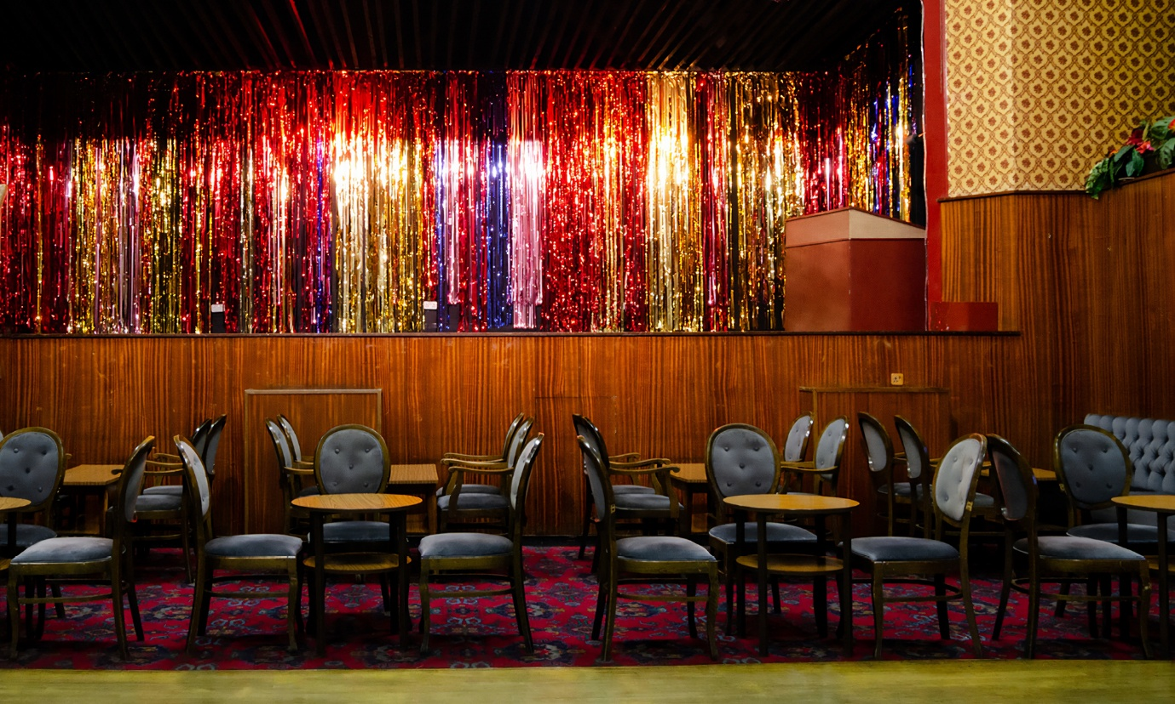
Factory International has today announced new projects from their Young Curators and Artist Takeover programmes for spring 2026 as well as the return of their Artists In Times of Upheaval series, which explore artists’ direct responses to global and national upheaval. All the work announced today is part of Factory International’s artist development and creative learning initiatives, dedicated to supporting artists at all stages of their journey.
Young Curtators and Trackie McLeod
The Young Curators, aged 30 and under, have spent the past year working with leading industry professionals and artists to create a large-scale installation, the culmination of which will be a takeover from artist Trackie McLeod in UTOPIA (19-21 February). The unique new installation is a loving nod to the working men’s clubs McLeod grew up in in Glasgow – playfully exploring identity, class, and gentrification by building a working, flat-roof pub inside Factory International’s iconic Warehouse space.
By day, UTOPIA is open as a pub, exhibition and workshop space – complete with the opportunity to explore new prints, sculpture, video and found-object work by Trackie McLeod. Audiences can also drop by for a free drink during Trackie’s Happy Hour each afternoon, while the artist himself works a shift behind the bar.
Come sundown, the pub transforms into an intimate venue which celebrates the grassroots talent of the city through a programme of free events selected by the Young Curators - featuring drag queen Bailey J Mills, round-table discussions with Rebecca Swarray aka DJ Mix-Stress, Dave Haslam and rebecca elizabeth shaw, a DJ set by Rainy Miller, live music by mamba.exe and Shahari, and a Saturday night takeover by The DBA.
The Young Curators programme launched in 2024 as an opportunity for six young Manchester creatives to explore curation and encourage younger audiences. The Young Curators for 2025-6 are - Anita Ezeh, Fauziya Johnson, Jack Clarke, Madison Marcantonatos, Otega Ajuchi, and Rachel Morgan.
John McGrath, Artistic Director and Chief Executive of Factory International says: “The Young Curators project is a truly exciting and radical part of Factory International’s artistic programme - handing decision-making over to a talented group of young creatives.
UTOPIA builds on the successes of our previous public curation programmes and develops our commitment to thinking about artistic venues in new ways.
We are particularly thrilled that this project results in a commission from such a significant up-and-coming talent as Trackie.”
Artist Trackie McLeod says: “I’m honoured to have been selected by the Young Curators to exhibit at Factory International. It’s an amazing opportunity, and Manchester and its people have always held a special place in my heart.
I often say you can tell how friendly a city is by how you’re treated in a smoking area and in Manchester, like in Glasgow, someone will always offer you a lighter.”
Artist Takeover: Chad Taylor
Dancer and choreographer Chad Taylor will collaborate with artist and curator Sean Clarke and arts production manager Joel Clements to take over the Hall in Aviva Studios for a week in February, to create a digital world using projection mapping as Factory International’s 2026 Artist Takeover.
Chad Taylor is the latest artist selected for Artist Takeover, following a call-out in September for collectives of movement artists, choreographers and dancers who are ready to expand their creative practice and explore how the worlds of movement and technology collide.
Now in its fifth year, Factory International’s Artist Takeover initiative will also be taking over Aviva Studios this February. The opportunity provides mid-career artists with a grant of up to £10,000, as well as the time, space and support to experiment at a scale not possible elsewhere.
Chad Taylor, Artist Takeover artist, dancer and choreographer says: “I’m over the moon about being selected for Factory International’s first ever dance/movement-based takeover.
“This opportunity has come at the best time for me as an artist and I’m very excited to see what comes out by the end of the takeover as right now it’s an unknown space for me. Beautiful things come from being in an unknown space.”
Artists in Times of Upheaval
Factory International's Artists in Times of Upheaval series returns in February, inviting audiences to engage with free talks and artistic projects emerging from artists' direct responses to global and national upheaval.
The programme will include a staged reading of Resisters (19 February), by award-winning writer and performer Mojisola Adebayo, directed by Omar Elerian. The piece focuses on the relationship between a Black British artist and a Palestinian artist - exploring queer and women's resistance to occupation, war and genocide through art.
Other events in the Artists in Times of Upheaval series include a reading of Antonina by Tetiana Kytsenko - a playwright and screenwriter living in Ukraine and writing about experiences of war - directed by Oleks Derevianko.
The 2026 series will feature a panel discussion centring on the Everyone Welcome project, spearheaded by arts event manager Cloe Gregson. The project launched in Manchester in 2025, with an invite to artists to reclaim the emblem of the St George’s cross as a symbol of inclusivity rather than fear and division, in response to the wave of England flags being raised across the UK.
Previous artists who have taken part in Artists in Times of Upheaval discussions include Ai Weiwei, Adania Shibli, Amir Nizar Zuabi, Kemang Wa Lehulere, Oleksit Radynski, Samson Young and Kaneza Schaal.
ENDS

DOWNLOAD HIGH RESOLUTION IMAGES HERE
For more information, please contact:
Anja Samy - Press Officer, Factory International
anja.samy@factoryinternational.org

NOTES TO EDITORS:
EVENT LISTINGS:
Artists in Times of Upheaval: Resisters, Palestine
19 February | The Hall, Aviva Studios
Book free tickets here
Experience a staged reading of Resisters, a new play by award-winning writer and performer Mojisola Adebayo, exploring queer and women's resistance to occupation, war and genocide through art.
Part of Artists in Times of Upheaval – a series exploring new artistic projects emerging from artists' direct responses to global and national upheaval.

UTOPIA
19 – 21 February | South Warehouse, Aviva Studios
(Press view: 19 February)
Free to attend, explore the full line-up of events here
UTOPIA is a working pub and installation that playfully explores nostalgia, class, identity, gentrification and the changing landscapes of Glasgow and Manchester.
Created by artist Trackie McLeod with Factory International’s Young Curators, UTOPIA revives the warmth of the working men’s clubs and flat-roofed pubs McLeod grew up in in Glasgow – by building a working pub inside Factory’s Warehouse space.
By day, UTOPIA is open as a pub, exhibition and workshop space – complete with new prints, sculpture, video and found-object works from Trackie McLeod. Come sundown, the pub transforms into an intimate venue for live music, performances and late-night gatherings.

Trackie McLeod’s UTOPIA: Trackie’s Happy Hour
19 – 21 February | South Warehouse, Aviva Studios
Free to drop in, find out more here
Trackie McLeod takes over the bar at UTOPIA for Happy Hour - explore Trackie’s artwork displayed around the pub and enjoy a free pint of Tennent’s lager or a soft drink.

Trackie McLeod’s UTOPIA: A night of Bailey J Mills
19 February | South Warehouse, Aviva Studios
(Press night)
Book free tickets here
Drag and comedy icon Bailey J Mills takes over UTOPIA’s stage for one night only.

Trackie McLeod’s UTOPIA Roundtable: Public House or Public’s Home?
20 February | South Warehouse, Aviva Studios
Book free tickets here
What do pubs mean to you, your community and our identity as a society? Hear explorations of family and local histories, pubs and their links to working class societies and politics, and what pubs mean to us personally. Featuring Rebecca Swarray – aka DJ, producer and curator Mix-Stress – and Dave Haslam – Haçienda DJ and bestselling writer, and DJ rebecca elizabeth shaw.

Trackie McLeod’s UTOPIA: Rainy Miller + mamba.exe
20 February | South Warehouse, Aviva Studios
Book free tickets here
UTOPIA evolves into an intimate live music venue with an atmospheric DJ set from Preston rapper and producer Rainy Miller– plus live rap from mamba.exe and music and spoken word from sonic storyteller Sharari.

Trackie McLeod’s UTOPIA: DBA takeover
21 February | South Warehouse, Aviva Studios
Book free tickets here
Join the party as UTOPIA transforms into a club hosted by legendary Manchester queer venue the DBA.

Trackie McLeod’s UTOPIA: T-Shirt Customisation Workshop
21 February | South Warehouse, Aviva Studios
Book free tickets here
UTOPIA is a creative space – head to the crafts table for a free t-shirt customisation workshop led by Factory International Young Curator Madison Marcantonatos from PSYRYN.

ARTIST BIOS:
ABOUT TRACKIE MCLEOD:
Trackie McLeod is a Scottish artist based in Glasgow. Trackie uses sculpture, textiles, video and print to explore his lived experience. He is interested in ideas of masculinity and queerness and their intersection with class, politics and popular culture. His visual language is innately Scottish, describing it as “one part tongue-in-cheek, an ounce of sarcasm and a pint of Tennent’s lager.
Trackie McLeod says: “Being selected by the Young Curators to exhibit at Factory International is an amazing opportunity, and I’m excited to present my work on a new scale and to a new audience.
“UTOPIA was conceived as an inclusive, safe, multi-purpose space for everyone, which aims to reintroduce a sense of togetherness at a time when much of our community exists online. Through this work, with the help of the Young Curators, I want to celebrate grassroots spaces and emerging talent. I hope the audience can use the space as a community hub for music, art, workshops, talks and, of course, a cheap pint.”

ABOUT FACTORY INTERNATIONAL’S YOUNG CURATORS:
Factory International's first cohort of Young Curators - Anita Ezeh, Fauziya Johnson, Jack Clarke, Madison Marcantonatos, Otega Ajuchi, and Rachel Morgan - are six young creatives based in Manchester, who are working with leading industry professionals and artists to explore curation. Their work considers how Factory International can encourage younger audiences.
Building on the success of public curation programmes such as ‘The Welcome’, where community members programmed every space at Aviva Studios for nine days, the Young Curators project develops Factory International’s commitment to thinking about artistic venues in new ways. After months of research, they’ve chosen to work with artist Trackie McLeod and create UTOPIA together – programming the evening performances and events.
Jack Clarke, Factory International Young Curator says: "Curating UTOPIA at Factory International means bringing working class stories back into the centre, not as nostalgia or pity, but as resistance."
Rachel Morgan, Factory International Young Curator says: “Being part of Factory International’s Young Curators programme feels like an expansive opportunity to work collaboratively. Co-curating the work of a multidisciplinary artist such as Trackie really reflects the programme’s emphasis on broad, cross-disciplinary ways of working.”
Find out more about the Young Curators here.

ABOUT CHAD TAYLOR:
Chad Taylor started dancing from the age of eleven, training in the foundations of hip hop. At fourteen years of age he started to widen his dance vocabulary through other styles such as ballet, tap, and jazz. His professional experience started at the young age of fifteen, when he appeared on TOTP and CD:UK.
At the age of nineteen, he graduated from the Hammond school with a National Diploma in Dance on a full scholarship. He then went on to work with artists such as Cheryl Cole, Paloma Faith, Sade, Take That, Meatloaf, Joe McElderry, Little Mix, LMFAO. He has worked with choreographers such as Fatima Robinson and has performed at the X-Factor final at the O2 Arena, the Brit Awards and the Royal Variety Show.
As a creative Chad Taylor is a dancer, choreographer, and writer known for his dynamic movement style, musicality, and strong creative vision. Trained across multiple styles, his work blends technical precision with raw expression, adapting seamlessly across stage, screen, and live performance. His choreography is driven by storytelling, emotion, and rhythm, often exploring themes of identity, connection, and individuality. Chad has collaborated with a wide range of artists, creatives, and organisations, bringing leadership and versatility to every project. Making a name for himself in the outdoor sector, his work Closer To My Dreams has toured fourteen festivals across eleven cities. Passionate about growth and collaboration, Chad approaches each piece with curiosity and intention, pushing boundaries while staying true to the music and integrity.

ABOUT MOJISOLA ADEBAYO:
Mojisola Adebayo is a playwright, performer, director, producer, workshop facilitator and lecturer. She has a BA in Drama and Theatre Arts, an MA in Physical Theatre and her PhD is entitled Afriquia Theatre: Creating Black Queer Ubuntu Through Performance (Goldsmiths, Royal Holloway and Queen Mary, University of London). Mojisola trained extensively with Augusto Boal and is an international specialist in Theatre of the Oppressed, often working in locations of crisis and conflict. She has worked in theatre, radio and television, on four continents, over the past 25 years, performing in over 50 productions, writing, devising and directing over 30 plays, and leading countless workshops, from Antarctica to Zimbabwe. Her own authored plays include Moj of the Antarctic: An African Odyssey (Lyric Hammersmith and Ovalhouse, London), Muhammad Ali and Me (Ovalhouse, Albany Theatre, London and UK touring), 48 Minutes for Palestine (Ashtar Theatre and international touring), Desert Boy (Albany Theatre, London and UK touring), The Listeners (Pegasus Theatre, Oxford), I Stand Corrected (Artscape, Ovalhouse, London and international touring) and The Interrogation of Sandra Bland (Bush Theatre, London).

ABOUT FACTORY INTERNATIONAL
Factory International is the organisation behind Manchester International Festival and the city’s landmark cultural space, Aviva Studios. Factory International commissions, produces and presents a year-round programme of original creative work and special events at Aviva Studios, online, and internationally through its network of co-commissioners and partners. It also stages the city-wide Manchester International Festival (MIF) every other year.
MIF is one of the world’s leading arts festivals, and the first to be entirely focused on the commissioning and producing of ambitious new work. Staged every two years in Manchester since 2007, the festival invites world-renowned artists from different art forms and backgrounds to create dynamic, innovative and forward-thinking new work in venues and spaces across Greater Manchester. Previous artists include, Björk, Jeremy Deller, Akram Khan, Yayoi Kusama, David Lynch, Wayne McGregor, Steve McQueen, Yoko Ono, Maxine Peake, Skepta, and The xx.
Factory International plays an important role in the lives of Greater Manchester residents, bringing jobs, skills, training and creative opportunities. Through the Factory Academy, Factory International is training the creative workforce of the future, while its pioneering creative engagement and artist development programmes create year-round opportunities for local people to get involved, from participating in flagship commissions to shaping the organisation through involvement in its public forums.
Aviva Studios was designed by the world-leading practice Office for Metropolitan Architecture (OMA), with Ellen van Loon as lead architect – their first major public building in the UK. Its development was led by Manchester City Council, with backing from HM Government and National Lottery funding from Arts Council England.
Factory International is an Arts Council England National Portfolio Organisation.
factoryinternational.org

ABOUT ARTS COUNCIL ENGLAND
Arts Council England is the national development agency for creativity and culture. We have set out our strategic vision in Let’s Create that by 2030 we want England to be a country in which the creativity of each of us is valued and given the chance to flourish and where everyone of us has access to a remarkable range of high-quality cultural experiences. From 2023 to 2026 are investing over £467 million of public money from Government and an estimated £250 million from The National Lottery each year to help support the sector and to deliver this vision.
www.artscouncil.org.uk

