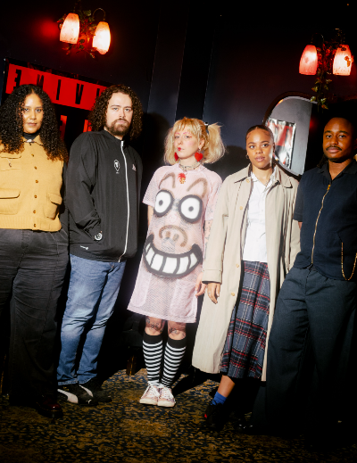

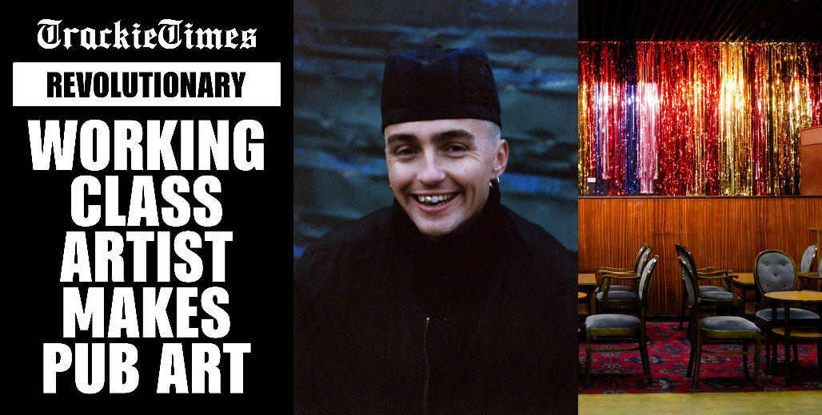
FACTORY INTERNATIONAL PRESENTS TRACKIE MCLEOD’s UTOPIA: A WORKING PUB INSTALLATION AND SERIES OF FREE LIVE EVENTS AND TAKEOVERS.
- UTOPIA, a working, flat-roof pub inside Factory International’s iconic Warehouse space, is a nod to the working men’s clubs that artist Trackie McLeod grew up with in Glasgow. Presented by Factory International’s Young Curators and McLeod it runs 19-21 February 2026.

- Split between a day and night programme, over the course of three days, UTOPIA will open as a pub, exhibition and workshop space, before transforming into an intimate venue of free events celebrating the grassroots talent of the city.
- The programme includes drag queen Bailey J Mills, round-table discussions with Rebecca Swarray aka DJ Mix-Stress, Dave Haslam and rebecca elizabeth shaw, a DJ set by Rainy Miller, live music by mamba.exe and Sharari, a Saturday night takeover by legendary queer venue The DBA featuring Phia Sky, Deventi, David James and Shanika Sunrise, followed by an after-party at the iconic converted pub The DBA calls home.
- Audiences can also drop by for a free drink during Trackie’s Happy Hour each afternoon, while the artist himself works a shift behind the bar.
As part of their groundbreaking Young Curators programme, Factory International announces UTOPIA by Trackie McLeod – a working pub inside the iconic Warehouse space of Aviva Studios that transforms across three days into an expansive day and night programme of live events and takeovers that celebrate the grassroots talent of the city.
The Young Curators, aged 30 and under, have spent the past year working with leading industry professionals and artists to create a large-scale installation, the culmination of which will be a takeover from artist Trackie McLeod in UTOPIA (19-21 February). The unique new installation is a loving nod to the working men’s clubs McLeod grew up in in Glasgow – playfully exploring identity, class, and gentrification by building a working, flat-roof pub inside Factory International’s iconic Warehouse space.
By day, UTOPIA is open as a pub, exhibition and workshop space – complete with the opportunity to explore new prints, sculpture, video and found-object work by Trackie McLeod.
Audiences can also drop by for a free drink during Trackie’s Happy Hour each afternoon, while the artist himself works a shift behind the bar.
Come sundown, the pub transforms into an intimate venue which celebrates the grassroots talent of the city through a programme of free events selected by the Young Curators - featuring drag queen Bailey J Mills, round-table discussions with Rebecca Swarray aka DJ Mix-Stress, Dave Haslam and rebecca elizabeth shaw, a DJ set by Rainy Miller, plus live rap from mamba.exe, spoken word from sonic storyteller Sharari, and a Saturday night takeover by iconic queer venue The DBA.
The Young Curators programme launched in 2024 as an opportunity for six young Manchester creatives to explore curation and encourage younger audiences. The Young Curators for 2025-6 are - Anita Ezeh, Fauziya Johnson, Jack Clarke, Madison Marcantonatos, Otega Ajuchi, and Rachel Morgan.
Artist Trackie McLeod says: “I’m honoured to have been selected by the Young Curators to exhibit at Factory International. It’s an amazing opportunity, and Manchester and its people have always held a special place in my heart.
I often say you can tell how friendly a city is by how you’re treated in a smoking area and in Manchester, like in Glasgow, someone will always offer you a lighter.”
The installation reflects on the loss of community spaces in Glasgow and Manchester due to gentrification and changing city life. UTOPIA aims to reintroduce a sense of togetherness at a time when much of our community exists online. It’s conceived as an inclusive, safe, multi-purpose space for everyone. Through this work, with the help of the Young Curators I want to celebrate grassroots spaces and emerging talent. I hope the audience can use the space as a community hub for music, art, workshops, talks and of course a cheap pint."
Young Curator Jack Clarke adds: “Trackie’s a kindred spirit, he doesn’t just get the vibe, he is the vibe. There’s a rebellious tenderness to his work that I’ve always gravitated toward, something that speaks to the mess and the joy and the stubborn resilience of nightlife, especially when it's disappearing in real time. Working with him is like throwing a spark into a room full of kindling, you don’t know exactly what’s gonna catch, but you know it’s going to burn bright.”
John McGrath, Artistic Director and Chief Executive of Factory International says: “The Young Curators project is a truly exciting and radical part of Factory International’s artistic programme - handing decision-making over to a talented group of young creatives.
UTOPIA builds on the successes of our previous public curation programmes and develops our commitment to thinking about artistic venues in new ways.
We are particularly thrilled that this project results in a commission from such a significant up-and-coming talent as Trackie.”
ENDS
DOWNLOAD HIGH RESOLUTION IMAGES HERE
For more information, please contact:
Anja Samy - Press Officer, Factory International
anja.samy@factoryinternational.org

NOTES TO EDITORS:
PROGRAMME SCHEDULE
UTOPIA
19 – 21 February | South Warehouse, Aviva Studios
(Press view: 19 February)
Free to attend, explore the full line-up of events here
UTOPIA is a working pub and installation that playfully explores nostalgia, class, identity, gentrification and the changing landscapes of Glasgow and Manchester.
Created by artist Trackie McLeod with Factory International’s Young Curators, UTOPIA revives the warmth of the working men’s clubs and flat-roofed pubs McLeod grew up in in Glasgow – by building a working pub inside Factory’s Warehouse space.
By day, UTOPIA is open as a pub, exhibition and workshop space – complete with new prints, sculpture, video and found-object works from Trackie McLeod. Come sundown, the pub transforms into an intimate venue for live music, performances and late-night gatherings.
Trackie McLeod’s UTOPIA: Trackie’s Happy Hour
19 – 21 February | South Warehouse, Aviva Studios
Free to drop in, find out more here
Trackie McLeod takes over the bar at UTOPIA for Happy Hour - explore Trackie’s artwork displayed around the pub and enjoy a free pint of Tennent’s lager or a soft drink.
Trackie McLeod’s UTOPIA: A night of Bailey J Mills
19 February | South Warehouse, Aviva Studios
(Press night)
Book free tickets here
Drag and comedy icon Bailey J Mills takes over UTOPIA’s stage for one night only.

Trackie McLeod’s UTOPIA Roundtable: Public House or Public’s Home?
20 February | South Warehouse, Aviva Studios
Book free tickets here
What do pubs mean to you, your community and our identity as a society? Hear explorations of family and local histories, pubs and their links to working class societies and politics, and what pubs mean to us personally. Featuring Rebecca Swarray – aka DJ, producer and curator Mix-Stress – and Dave Haslam – Haçienda DJ and bestselling writer, and DJ rebecca elizabeth shaw.

Trackie McLeod’s UTOPIA: Rainy Miller + mamba.exe + Sharari
20 February | South Warehouse, Aviva Studios
Book free tickets here
UTOPIA evolves into an intimate live music venue with an atmospheric DJ set from Preston rapper and producer Rainy Miller– plus live rap from mamba.exe and music and spoken word from sonic storyteller Sharari.

Trackie McLeod’s UTOPIA: T-Shirt Customisation Workshop
21 February | South Warehouse, Aviva Studios
Book free tickets here
UTOPIA is a creative space – head to the crafts table for a free t-shirt customisation workshop led by Factory International Young Curator Madison Marcantonatos from PSYRYN.
Trackie McLeod’s UTOPIA: DBA takeover
21 February | South Warehouse, Aviva Studios
Book free tickets here
Join the party as UTOPIA transforms into a club hosted by legendary Manchester queer venue The DBA featuring Phia Sky, Deventi, David James and Shanika Sunrise.

Trackie McLeod's UTOPIA [AFTERPARTY]
21 February | The DBA, Cheetham Hill
Book tickets here
Line-up TBA

ARTIST BIOS:
ABOUT TRACKIE MCLEOD:
Trackie McLeod is a Scottish artist based in Glasgow. Trackie uses sculpture, textiles, video and print to explore his lived experience. He is interested in ideas of masculinity and queerness and their intersection with class, politics and popular culture. His visual language is innately Scottish, describing it as “one part tongue-in-cheek, an ounce of sarcasm and a pint of Tennent’s lager.
Trackie McLeod says: “Being selected by the Young Curators to exhibit at Factory International is an amazing opportunity, and I’m excited to present my work on a new scale and to a new audience.
“UTOPIA was conceived as an inclusive, safe, multi-purpose space for everyone, which aims to reintroduce a sense of togetherness at a time when much of our community exists online. Through this work, with the help of the Young Curators, I want to celebrate grassroots spaces and emerging talent. I hope the audience can use the space as a community hub for music, art, workshops, talks and, of course, a cheap pint.”

ABOUT FACTORY INTERNATIONAL’S YOUNG CURATORS:
Factory International's first cohort of Young Curators - Anita Ezeh, Fauziya Johnson, Jack Clarke, Madison Marcantonatos, Otega Ajuchi, and Rachel Morgan - are six young creatives based in Manchester, who are working with leading industry professionals and artists to explore curation. Their work considers how Factory International can encourage younger audiences.
Building on the success of public curation programmes such as ‘The Welcome’, where community members programmed every space at Aviva Studios for nine days, the Young Curators project develops Factory International’s commitment to thinking about artistic venues in new ways. After months of research, they’ve chosen to work with artist Trackie McLeod and create UTOPIA together – programming the evening performances and events.
Jack Clarke, Factory International Young Curator says: "Curating UTOPIA at Factory International means bringing working class stories back into the centre, not as nostalgia or pity, but as resistance."
Rachel Morgan, Factory International Young Curator says: “Being part of Factory International’s Young Curators programme feels like an expansive opportunity to work collaboratively. Co-curating the work of a multidisciplinary artist such as Trackie really reflects the programme’s emphasis on broad, cross-disciplinary ways of working.”
Find out more about the Young Curators here.

ABOUT FACTORY INTERNATIONAL
Factory International is the organisation behind Manchester International Festival and the city’s landmark cultural space, Aviva Studios. Factory International commissions, produces and presents a year-round programme of original creative work and special events at Aviva Studios, online, and internationally through its network of co-commissioners and partners. It also stages the city-wide Manchester International Festival (MIF) every other year.
MIF is one of the world’s leading arts festivals, and the first to be entirely focused on the commissioning and producing of ambitious new work. Staged every two years in Manchester since 2007, the festival invites world-renowned artists from different art forms and backgrounds to create dynamic, innovative and forward-thinking new work in venues and spaces across Greater Manchester. Previous artists include, Björk, Jeremy Deller, Akram Khan, Yayoi Kusama, David Lynch, Wayne McGregor, Steve McQueen, Yoko Ono, Maxine Peake, Skepta, and The xx.
Factory International plays an important role in the lives of Greater Manchester residents, bringing jobs, skills, training and creative opportunities. Through the Factory Academy, Factory International is training the creative workforce of the future, while its pioneering creative engagement and artist development programmes create year-round opportunities for local people to get involved, from participating in flagship commissions to shaping the organisation through involvement in its public forums.
Aviva Studios was designed by the world-leading practice Office for Metropolitan Architecture (OMA), with Ellen van Loon as lead architect – their first major public building in the UK. Its development was led by Manchester City Council, with backing from HM Government and National Lottery funding from Arts Council England.
Factory International is an Arts Council England National Portfolio Organisation.
factoryinternational.org

ABOUT ARTS COUNCIL ENGLAND
Arts Council England is the national development agency for creativity and culture. We have set out our strategic vision in Let’s Create that by 2030 we want England to be a country in which the creativity of each of us is valued and given the chance to flourish and where everyone of us has access to a remarkable range of high-quality cultural experiences. From 2023 to 2026 are investing over £467 million of public money from Government and an estimated £250 million from The National Lottery each year to help support the sector and to deliver this vision.
www.artscouncil.org.uk

